**Part 2: Texturing**

Non-Textured:

Front View

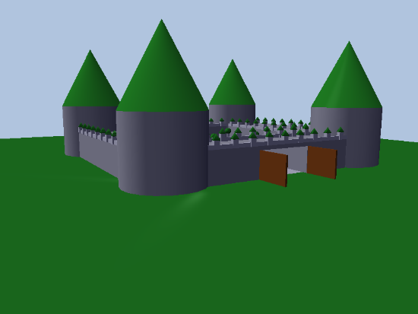

Top View

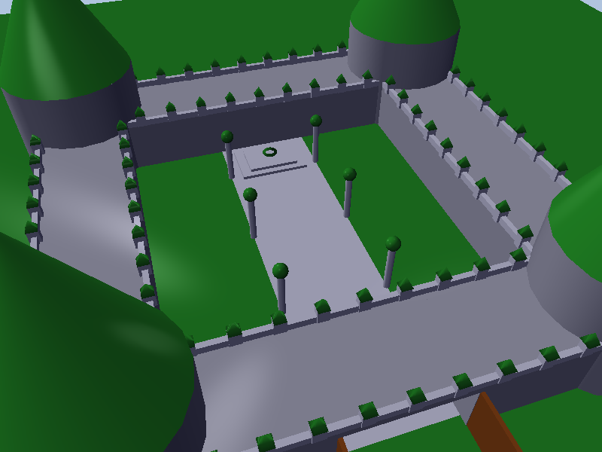

Inside View

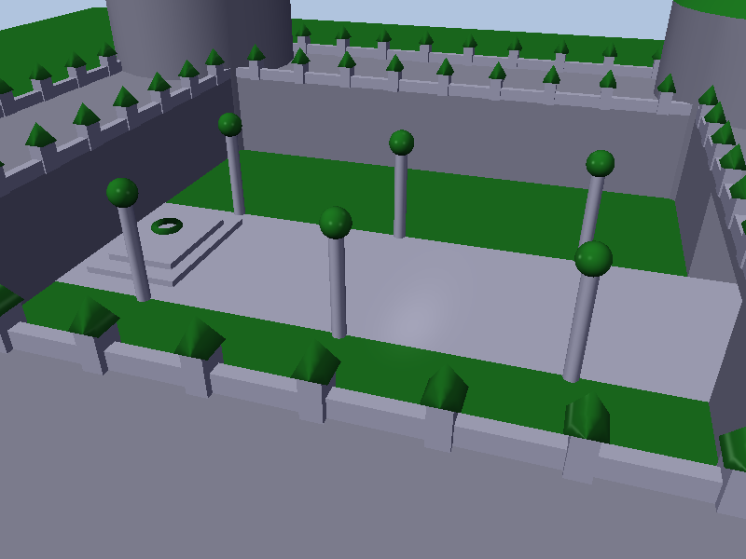

Textured:

**Materials Used**:

Grass - Inside castle floor

Tile - Floor inside castle leading to podium and maze floor

Metal -Light pole inside castle

Glass – On top of light pole for light source

Stone - Podium steps holding Torus at the back of the castle/Rails on castle walls

Ice – Torus placed at the back of the castle

Wood – Cones on top of the main walls/rails on the top sides/front gates

Stone – Main castle cylinders/walls connecting the cylinder/maze walls

Trees – Tree textures placed around the castle

Side View

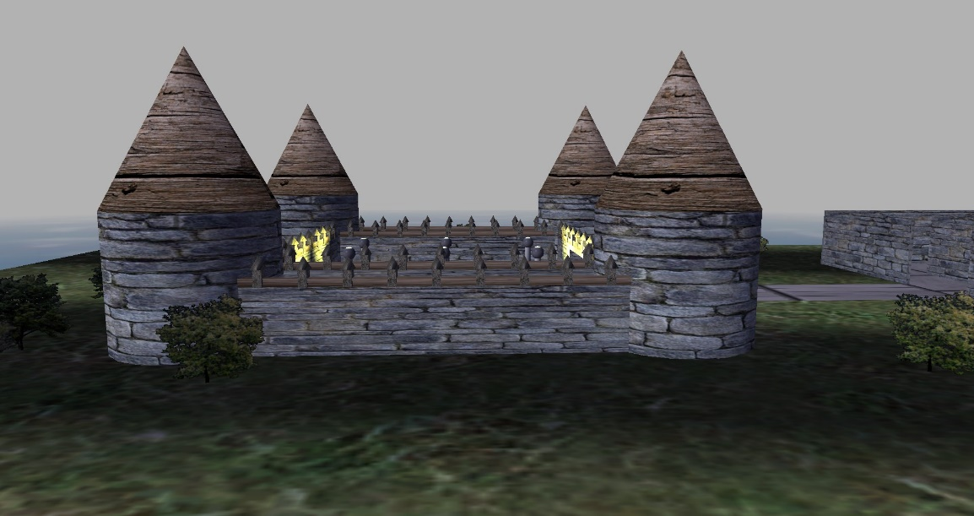

Front View

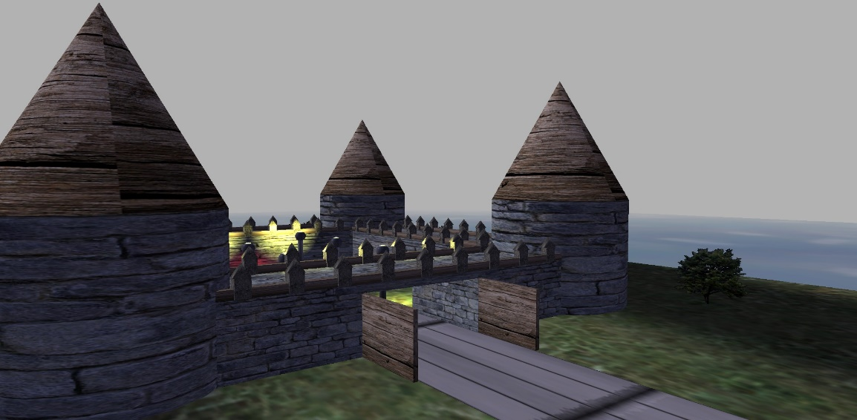

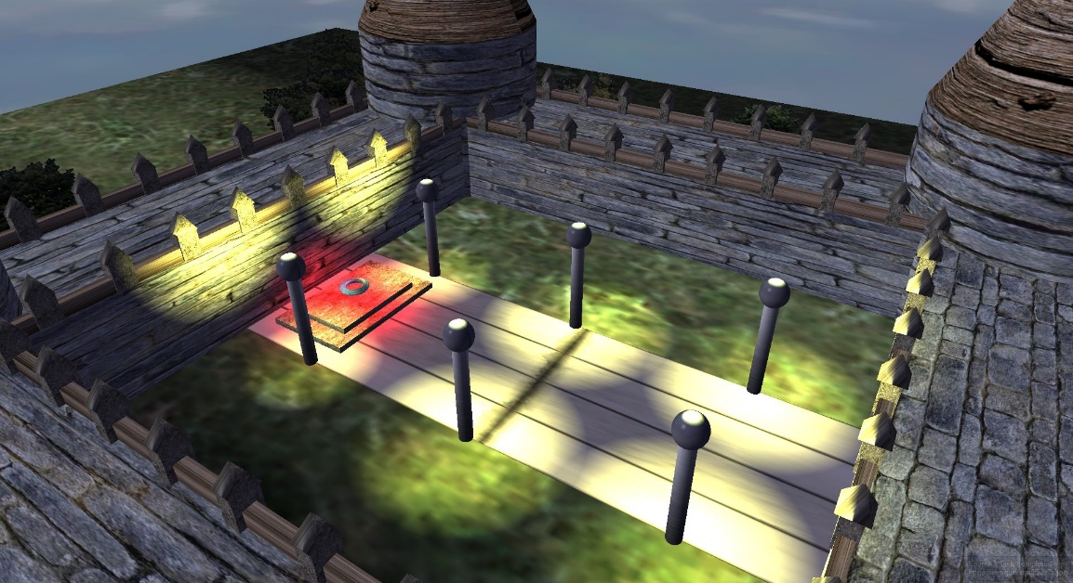Inside View

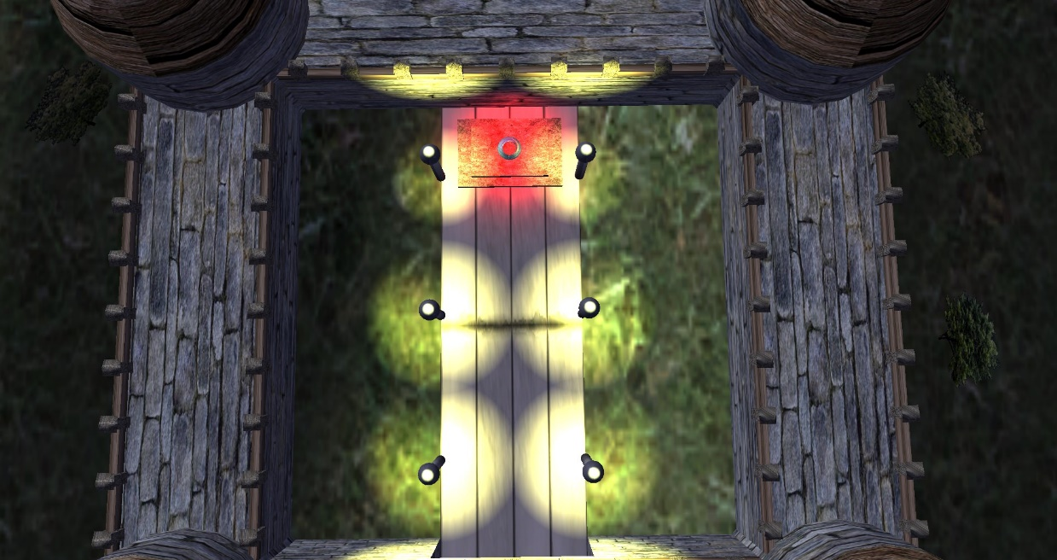Top-down Inside view

Maze Inside View

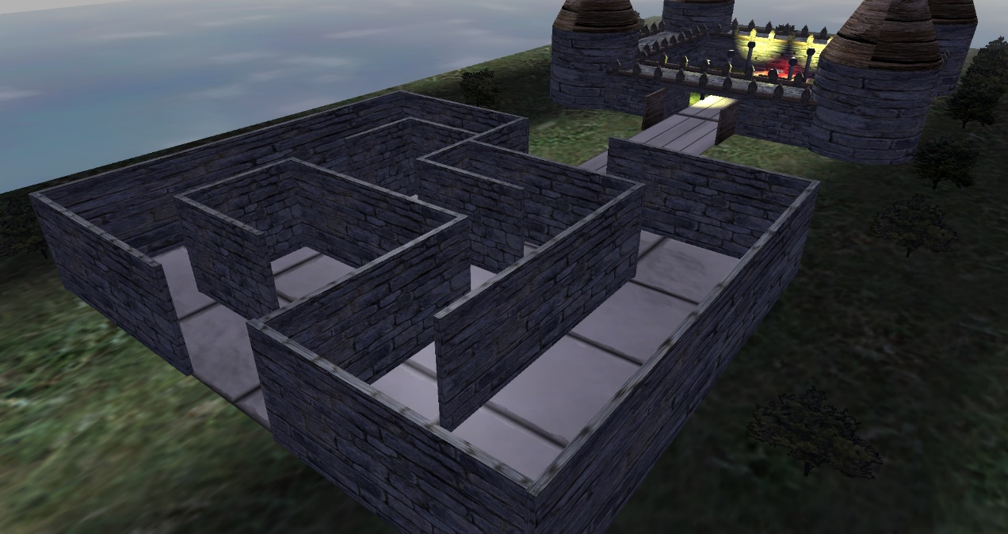

Top-down Maze View

